The Nature and Origin
of Instructional Objects

Andrew S. Gibbons
Jon Nelson

Utah State University

Robert Richards

Idaho National Engineering and Environmental Laboratory

Introduction

This chapter examines the nature and origin of a construct we term the instructional object. Rather than being a single definable object, it is a complex and multi-faceted emerging technological construct—one piece of a larger technological puzzle. The general outlines of the puzzle piece are taking shape concurrently in the several disciplines from which the practices of instructional technology are derived—computer science, information technology, intelligent tutoring systems, and instructional psychology. The terminology used to describe this new idea reflects its multiple origins, its diverse motivations, and its newness. In the literature what we will refer to as the “instructional object” is termed variously “instructional object,” “educational object,” “learning object,” “knowledge object,” “intelligent object,” and “data object.” Our work is most heavily influenced by the work of Spohrer and his associates on educational object economies (Spohrer, Sumner & Shum, 1998).

Much has been written about instructional objects but little about how objects originate. This chapter examines instructional objects in the context of a complex instructional design space. We propose the dimensions of this space and to use that as a background for relating together the multiple definitions of the instructional object. We then try to situate the new construct within a context of design activities that differs from traditional design process views. We finish by describing criteria and methodology guidelines for generating objects.

As the instructional object continues to take on definition and proportions, and as work in many fields converges, we believe instructional objects in some form will become a major factor in the growth and proliferation of computer-based instruction and performance support technology.

Analysis and Instructional Objects

The long-range purpose of this research is to consolidate a theory of instructional design that uses the “model” as a central design construct. Such a base will support systematic future research into product varieties, product architectures, production efficiencies, and specialized productivity tools. By doing so, we are hoping to link the practice of instructional designers with new design constructs implied by current views of instruction that are shifting toward student-centered, situated, problem-based, and model-centered experiences—ones that are also shaped by the demands of scaling and production efficiency.

We believe that this discussion is timely. Even as the instructional use of the World Wide Web is being promoted with increasing urgency, there are serious questions concerning whether it is fully provided with design concepts, architectures, and tools that fit it for service as a channel for instructing rather than merely informing (Fairweather & Gibbons, 2000). At the same time, instructional design theorists are questioning the assumptions underlying existing design methodologies that are proving brittle in the face of challenges posed by the newer instructional modes (Gordon & Zemke, 2000; Reigeluth, 1999; Edmonds, Branch & Mukherjee, 1994; Rowland, 1993). The instructional object has been proposed within different specialty fields for its productivity benefits, for its standardization benefits, and as a means of making design accessible to a growing army of untrained developers. As the design process evolves a theoretic base, we feel it important to ask how that theory base can be related to instructional objects.

Standards and CBI Technology

The industry that focuses on the design, development, and delivery of computerized instruction is currently undergoing a period of standard setting focused on the distribution of instructional experiences over the Internet and World Wide Web. The instructional object—indexed by metadata—has great potential as a common building block for a diverse range of technology-based instructional products. Massive efforts involving hundreds of practitioners, suppliers, and consumers are contributing to object standards that will allow this building block to become the basic unit of commerce in instruction and performance support (Hill, 1998).

It is hard to resist comparing these events with events in the history of the steel-making technology. When Frederick Taylor showed in the opening years of the 20th century that reliable recipes for steel could be placed into the hands of relatively untrained furnace operators (Misa, 1995), an army of new and less-trained but fully competent furnace operators began to take over the mills. Greater quantities of steel (industrial scale) could be produced at more precisely controlled levels of quality. Three key events in the expansion of steel making involved epochs of standard setting carried out by three different standards coalitions. Over several decades, these coalitions arbitrated the measures of product quality for rail steel, structural steel, and automotive steel respectively. With each new standard, the industry progressed and expanded. This in turn led to even more rapid expansion and diversification of the use of steel in other products.

Steel standards paved the way for: (1) the achievement of more precise and predictable control over steel manufacturing processes, (2) a standard-based product that could be tailored to the needs of the user, and (3) the ability to scale production to industrial proportions using the new processes (Misa, 1995). Without these developments, steel quality would still be highly variable, steel products would have a much narrower range, and steel making would still be essentially an idiosyncratic craft practiced by highly trained and apprenticed furnace operators.

The Nature of Instructional Objects

We define instructional objects in a later section of this chapter by relating them to an architecture for model-centered instructional products. As we use the term in this chapter, instructional objects refer to any element of that architecture that can be independently drawn into a momentary assembly in order to create an instructional event. Instructional objects can include problem environments, interactive models, instructional problems or problem sets, instructional function modules, modular routines for instructional augmentation (coaching, feedback, etc.), instructional message elements, modular routines for representation of information, or logic modules related to instructional purposes (management, recording, selecting, etc.).

The literature in a number of disciplines that contribute to instructional technology describes objects that perform some subset of the functions required of the different kinds of instructional object:

- Objects involved in database structuring
- Objects for the storage of expert system knowledge
- Objects for document format control
- Objects used for development process control
- Modular, portable expert tutors
- Objects representing computer logic modules for use by non-programmers
- Objects for machine discovery of knowledge
- Objects for instructional design
- Objects containing informational or message content
- Objects for knowledge capture
- Objects that support decision making
- Objects for data management

All of these types of object and more are needed to implement instruction through the real-time assembly of objects. Gerard (1969) in a surprisingly visionary statement early in the history of computer-based instruction describes how “curricular units can be made smaller and combined, like standardized Meccano [mechanical building set] parts, into a great variety of particular programs custom-made for each learner” (p. 29-30). Thirty years later, the value and practicality of this idea is becoming apparent.

Basic Issues

To set the stage for the discussion of instructional object origins, it is essential to touch briefly on two issues related generally to the design and development of technology-based instruction:

- The goals of computerized instruction: adaptivity, generativity, and scalability
- The structure of the technological design space

The Goals of Computerized Instruction: Adaptivity, Generativity, and Scalability

From the earliest days of computer-based instruction as a technology, the goal has clearly been creating instruction that was: (1) adaptive to the individual, (2) generative rather than pre-composed, and (3) scalable to industrial production levels without proportional increases in cost.

Nowhere are these ideals more clearly stated than in Computer-Assisted Instruction: A Book of Readings (1969a), a ground-breaking and in many ways still current volume edited by Atkinson and Wilson. Virtually all of the chapters selected for the book build on the three themes: adaptivity, generativity, and scalability.

Adaptivity: Atkinson and Wilson credit the rapid rate of growth (before 1969) in CAI in part “to the rich and intriguing potential of computer-assisted instruction for answering today’s most pressing need in education—the individualization of instruction” (Atkinson & Wilson, 1969b, p. 3). They distinguish CAI that is adaptive from that which is not, attributing the difference to “response sensitive strategy.” Suppes (1969) foresees “a kind of individualized instruction once possible only for a few members of the aristocracy” that can “be made available to all students at all levels of abilities” (p. 41). This durable argument is being used currently to promote instructional object standards (Graves, 1994).

Suppes (1969) describes how computers will “free students from the drudgery of doing exactly similar tasks unadjusted and untailored to their individual needs.” (p. 47). Stolurow (1969), describing models of teaching, explains:

…must be cybernetic, or response-sensitive, if it is adaptive. A model for adaptive, or personalized, instruction specifies a set of response-dependent rules to be used by a teacher, or a teaching system, in making decisions about the nature of the subsequent events to be used in teaching a student. (p. 69-70)

He introduces an “ideographic” instructional model that designs for “possibilities” rather than plans for specific paths: “we need ways to describe the alternatives and we need to identify useful variables” (p. 78). Stolurow makes the important distinction “between branching and contingency or response-produced organization [of instruction]” (p. 79). These and many other things that could be cited from the Atkinson and Wilson volume make it clear that adaptivity was a closely-held early goal of computer-based instruction. Incidentally, these and other statements in the book make it clear that CAI was not envisioned by these pioneers as simply computerized programmed instruction.

Generativity: Generativity refers to the ability of computerized instruction to create instructional messages and interactions by combining primitive message and interaction elements rather than by storing pre-composed messages and interaction logics. The contributors to Atkinson and Wilson describe mainly pre-composed instructional forms because in the early days of CAI there were no tools to support generativity, but many Atkinson and Wilson paper authors emphasize future tooling for generativity.

Suppes (1969), who later produced math problem generation tools himself, describes three levels of interaction between students and instructional programs, all of them subject to some degree of generativity: (1) individualized drill-and-practice, (2) tutorial systems that “approximate the interaction a patient tutor would have with an individual student,” and (3) dialogue systems “permitting the student to conduct a genuine dialogue with the computer” (p. 42-44).

Silberman (1969) describes the use of the computer to generate practice exercises (p. 53). Stolurow, describing the instructional rules of an adaptive system said:

These rules [for controlling presentation of information, posing of a problem, acceptance of a response, judging the response, and giving feedback] also can be called organizing rules; they are the rules of an instructional grammar. Eventually we should develop generative grammars for instruction. (p. 76)

Scalability: The authors of the Atkinson and Wilson volume were sensitive to the (then) highly visible costs of computer-assisted instruction. Their solutions to scalability were projections of lower computer costs, expectations for larger multi-terminal systems, and calculations of product cost spread over large numbers of users. The connective and distributive technology of the day was the time-shared monolithic centralized mainframe system and (then) high-cost and low-quality telephone lines.

The goals of adaptivity, generativity, and scalability that prevailed in 1969 are still key targets. These goals were adopted by researchers in intelligent tutoring systems, and they are clearly evident in the writings of that group of researchers, especially in the occasional summaries of the field and its evolving theory and method (Wenger, 1987; Psotka, Massey, & Mutter, 1988; Poulson & Richardson, 1988; Burns, Parlett, & Redfield, 1991; Noor, 1999).

Burns and Parlett (1991) tell us to, “Make no mistake. ITSs are trying to achieve one-on-one instruction, and therein lies the complexity and the necessary flexibility of any potentially honest ITS design.”

Today the tutorial systems and dialogue systems described by Suppes still represent cutting edge goals for intelligent tutoring systems. Generativity is still clearly a part of the basic game plan. This is evident in the goals of the Department of Defense Advanced Distributed Learning System Initiative (Advanced Distributed Learning Initiative, no date). As Burns and Parlett (1991) explain,

ITS designers have set up their own holy grail. The grail is, as you might have guessed, the capability for a large-scale, multiuser knowledge base to generate coherent definitions and explanations. It goes without saying that if a student has a reasonable question, then an ITS should have an answer. (p. 6)

The personal computer, the network, and rapidly proliferating communications connectivity have become the standard. Because of this, our focus on scalability has shifted from delivery costs to development costs. One of the forces behind the instructional objects phenomenon is the prospect of lowering product costs through a number of mechanisms: reusability, standardized connectivity, modularity to optimize transmission from central stores, and standardized manufacture.

The Structure of the Technological Design Space: The Convergence Zone

Technologies often develop first as ad hoc systems of practice that later must be grounded in technological theory and form a mutually contributory exchange with scientific theory. Instructional technology is seeking its theoretical foundations more vigorously now than ever before (Merrill, 1994; Reigeluth, 1999; Hannafin, et al., 1997). We believe that several clues to developing a more robust theoretical basis for instructional technology can come from studying technology as a type of knowledge-seeking activity and from studying the technological process.

Technology consists of the human work accomplished within a "convergence zone" where conceptual artifacts (designed structures, construct architectures) are given specific form with materials, information, and force-information transfer mechanisms. In this convergence zone, conceptual artifacts are linked with material or event artifacts that express a specific intention. In a discussion of the World Wide Web and Model-Centered Instruction, Gibbons and his associates (Gibbons, et al., in press) describe this convergence zone in terms of conceptual instructional constructs being realized using the programming constructs of a particular software tool.

This is the place where the designer’s abstract instructional constructs and the concrete logic constructs supplied by the development tool come together to produce an actual product. At this point, the abstract event constructs are given expression—if possible—by the constructs supplied by the development tool.

Burns and Parlett (1991) provide a glimpse of this boundary world:

Proposed architectures for representing teaching knowledge in ITSs can be described in terms of how knowledge is understood by experts and how it can be represented by programmers in sets of domain-independent tutoring strategies. (p. 5-6)

Herbert Simon, in Sciences of the Artificial, describes this convergence zone between the abstract world and the concrete world as a key to understanding technological activity in general:

I have shown that a science of artificial phenomena is always in imminent danger of dissolving and vanishing. The peculiar properties of the artifact lie on the thin interface between the natural laws within and the natural laws without. What can we say about it? What is there to study besides the boundary sciences—those that govern the means and the task environment?
The artificial world is centered precisely on this interface between the outer and inner environments; it is concerned with attaining goals by adapting the former to the latter. The proper study of those who are concerned with the artificial is the way in which that adaptation of means to environments is brought about—and central to that is the process of design itself. The professional schools will reassume their professional responsibilities just to the degree that they can discover a science of design, a body of intellectually tough, analytic, partly formalizable, partly empirical, teachable doctrine about the design process. (p. 131-2)

Simon emphasizes the fragility of the connections across the interface between conceptual and real: the interface is difficult to imagine in the abstract, and it is not surprising that many designers—especially novice ones—focus their attention mainly on the material result of designing rather than on its conceptual precursors. In fact, as we explain in a later section of this chapter, the focus of designers on a particular set of design constructs allows classification of designers into a number of broad classes.

Dimensions of the Design Space

Technologists who succeed in visualizing this conceptual-material boundary can be baffled by its complexity. Designs are never the simple, unitary conceptions that we describe in textbook terms. Instead, they are multi-layered constructions of mechanism and functionality whose interconnections require several transformational links to reach across the conceptual-material boundary. Links and layers both must articulate in designs such that interference between layers is minimized and the future adaptability of the artifact to changing conditions is maximized—the factor that gives the artifact survivability. Automated design systems provide principled guidance for those decisions that cannot be automated and default values for those that can.

Brand (1994) describes the principle of layering in designs by describing the layered design of building—in what he calls the “6-S” sequence:

- SITE – This is the geographical setting, the urban location, and the legally defined lot, whose boundaries and context outlast generations of ephemeral buildings. “Site is eternal, “ Duffy agrees.

- STRUCTURE – The foundation and load-bearing elements are perilous and expensive to change, so people don’t. These are the building. Structural life ranges from 30 to 300 years (but few buildings make it past 60, for other reasons).

- SKIN – Exterior surfaces now change every 20 years or so, to keep with fashion and technology, or for wholesale repair. Recent focus on energy costs has led to reengineered Skins that are air-tight and better insulated.

- SERVICES – These are the working guts of a building: communications wiring, electrical wiring, plumbing, sprinkler system, HVAC (heating, ventilating, air conditioning), and moving parts like elevators and escalators. They wear out or obsolesce every 7 to 15 years. Many buildings are demolished early if their outdated systems are too deeply embedded to replace easily.

- SPACE PLAN – The interior layout—where walls, ceilings, floors, and doors go. Turbulent commercial space can change every 3 years or so; exceptionally quiet homes might wait 30 years.

- STUFF – Chairs, desks, phones, pictures, kitchen appliances, lamps, hair brushes; all the things that twitch around daily to monthly. Furniture is called mobilia in Italian for good reason. (p. 13)

The aging of layers at different rates suggests that layers should be designed to “slip” past each other so that when they require change, update, renewal, or revision on different time cycles that can be accomplished without razing the whole structure. Brand relates the essential interconnections between these layers to the longevity of the artifact:

A design imperative emerges. An adaptive building has to allow slippage between the differently-paced systems of Site, Structure, Skin, Services, Space plan, and Stuff. Otherwise the slow systems block the flow of the quick ones, and the quick ones tear up the slow ones with their constant change. Embedding the systems together may look efficient at first, but over time it is the opposite, and destructive as well. (p. 20)

Brand explains that “the 6-S sequence is precisely followed in both design and construction.” Each layer of a design presents a separate design sub-problem to the designer. Layers must possess their own design integrity, but the structures of each layer must articulate with the structures of the other layers.

Figure 1 suggests the degree of multi-staging and multi-layering at Simon’s technology-producing “interface” by illustrating:

- Design layers (the vertical dimension of the figure) as they might be defined for instructional designers
- The progressive sequence of integrations or construct-to-construct links (the horizontal dimension of the figure) through which the original conception of a design emerges into an actual artifact
- The interconnections (angled lines) between the layers of a design show that each layer can be articulated with every other layer.

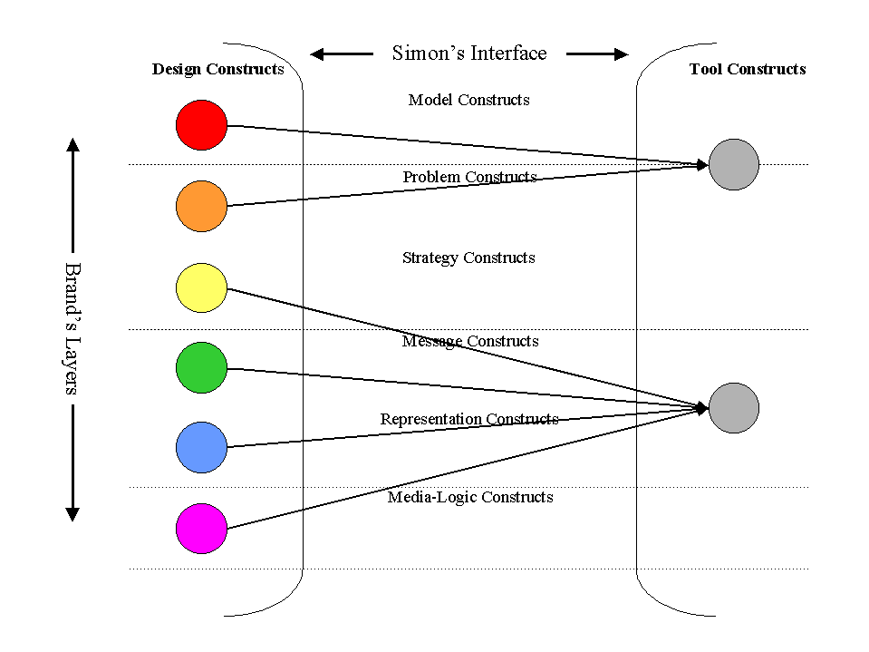
Figure 1. Multi-staging and multi-layering of an instructional design space.

As a design progresses from the conceptual stage to the real artifact stage, the integration of the layers increases to the point where abstract design and concrete product layers can barely be distinguished. Thus the structure and service layers of a building disappear behind covering walls and exterior skin; thus the model and media-logic layers of an instructional artifact disappear behind the strategy and surface representation layers. Since the tangible surface layers of a design are what we experience, it is not surprising that new designers fail to see the multiple layers of structure that are actually designed. This is typical with building designs, and it is especially typical with instructional designs.

Instructional designers can be classified generally in terms of the constructs they envision within a design—the constructs therefore that they are most liable to use to create the central structures of their designs:

- Media-centric designers tend to concentrate on media-related constructs and their arrangement (e.g., manuals, pages, cuts, transitions, synchronizations, etc.)
- Message-centric designers tend to constructs related to “telling” the instructional message in a way that supports its rapid uptake and integration with prior knowledge (e.g., analogy, advance organizer, use of conceptual figures, dramatization, etc.)
- Strategy-centric designers prefer to place structures and sequences of strategic elements at the center of their designs (e.g., message componentization, interaction patterns, interaction types, etc.)
- Model-centric designers tend to build their designs around central, interactive models of environments, cause-effect systems, and performance expertise and supplement them with focusing problems and instructional augmentations

Designers tend to move through these “centrisms” as personal experience accumulates and the value of new, less visible, subtler constructs becomes apparent to them. With each move to a new viewpoint the designer gains the use of the new design constructs without giving up the old ones, so this change results in the accumulation of fundamental design building blocks.

When instructional objects are used in design, they are constructs within Simon’s design space. They can theoretically be media, message, strategy, or model objects or any combination of these interacting across several layers. They can represent a functional instructional product having a many-layered design or a single element that can be integrated at the time of instruction into products to supply some modular functionality in a cooperative way.

The Origin of Instructional Objects

Prior to the notion of instructional objects, descriptions of the instructional design process have been couched in the terminology of other kinds of constructs considered to be produced at some point during design.
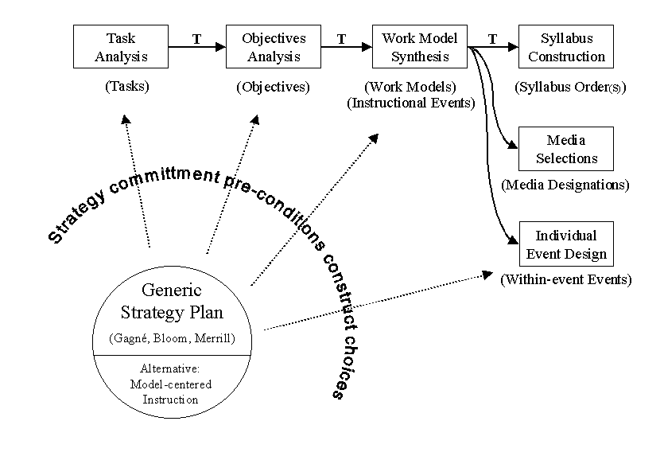
Figure 2 depicts the traditional ISD process in relation to Simon’s technology interface. Design is typically seen as deriving from each other, in succession, structural elements that permit requirements tracing of design elements back to a foundation of analysis elements. In Figure 2 this chain of analysis and design constructs begins with tasks obtained through task analysis that are used as a base for deriving objectives, which are in turn used as a base for deriving work models (including instructional events, see Gibbons, Bunderson, Olsen, & Robertson, 1995).

Figure 2. Generation of instructional design constructs within the abstract side of the design space, showing the preconditioning of constructs by instructional assumptions.

The “Ts” on the diagram indicate rule-guided transformations using the base construct to obtain a resultant construct. Links not marked with a “T” consist of attaching qualities or properties to an already-existing construct. The diagram could be more detailed, but in its present form it illustrates how a progression of analysis constructs (tasks, objectives) eventually links forward to design constructs (work models, instructional events) which constitute the design. At this point designers bridge across Simon’s gap by linking the constructs that make up the design with media and tool constructs (logic structures, media structures, representations, concrete objects).

Conceptions of the design process are idiosyncratic to designers. Different designers link different constructs through different derivational chains. The goal of Figure 2 is to show how a typical designer view can be related to several generations of abstract constructs on one side of Simon’s gap that link from the abstract realm into a concrete realm whose constructs are traceable. A different version of the design process would produce a diagram similar to Figure 2 that linked different elements. All of Figure 2 fits within the leftmost third of Figure 1, so all of the structures shown in Figure 2 are abstract. Development steps that build the bridge to tool and media constructs may give rise to directly corresponding media and tool objects through a process called “alignment” (see Duffin & Gibbons, in preparation).

Regardless of the specific constructs used by a designer, their mapping across Simon’s technology gap can be accomplished in the same manner. Thus, Simon’s description of this interface describes an underlying design space, and this allows design methodologies to be compared—on the basis of the constructual elements used in linkages on both sides of the gap. Instructional objects have constructual existence on both sides: they represent a particular alignment of abstract design, abstract media, and concrete tool constructs.

The Influence of Instructional Views on Design Constructs

Figure 2 also depicts how the designer’s preconceptions regarding instructional methods pre-condition the choice of analysis and design constructs derived on the left side of the gap. A designer subscribing to behavioral principles will derive analysis elements consisting of operant chains and individual operant units. These will link forward to produce a traceable lineage of compatible derived elements. One inclined toward structured strategic approaches to instruction will derive elements that correspond to the taxonomy underlying the particular strategic viewpoint. A Gagne advocate will produce tasks and objectives that correspond with Gagne’s learning types; a Bloom advocate will produce analysis units that correspond with Bloom’s. Merrill’s transaction types (Merrill, et al., 1996) serve a similar function. Many designers or design teams, rather than adhering to the constructs of a particular theorist, construct their own categorization schemes. Often these are conditioned by the subject matter being instructed and consist of blends of both theoretic and practically-motivated classes of constructs. These pre-condition the analysis constructs derived and subsequently the chain of constructs that result.

The designer’s instructional assumptions thus exercise a subtle but real influence in ways not always fully recognized by everyday designers. The strategic viewpoint acts as a DNA-like pattern, and if it is applied consistently throughout analysis and design can afford the designer product consistency and development efficiency. If the designer is not influenced by a particular strategic viewpoint, the analysis and design constructs linked by derivation can consist of message-delivery constructs or media delivery constructs. In this way Figure 2 can also be related to the four “centrisms” described earlier.

The process of mapping of constructs first within the abstract side of the technological design space and then across the gap to the concrete side is robust to an enormous variety of personally-held instructional design models. It is possible to identify, even in the work of designers who deny having a consistent single approach to design, a pattern of constructs and derivative relationships that bridge the abstraction-concretion gap. We propose that this type of designer is most common because most designers encounter a broad range of design problem types, and construct output from analysis can differ from project to project. It follows logically that this would involve at least some variation in the form and derivation links for those output constructs as well.

In the face of calls for design models adapted specifically to the needs of educators or industrial designers, the view of design we are outlining provides a vehicle for understanding differences. This applies as well to the notion of tailored design processes, partial or local design processes, and process descriptions adapted to the needs of a particular project. It is also possible to see how in iterative design-development processes one of the things that can evolve throughout the project is the nature of the design and analysis constructs themselves.

Implications for Instructional Objects

The constructs used in a design space and their derivative relationships are the key to understanding the origins and structures of any design. The instructional object enters this design space as a potentially powerful construct that must find its place within a fabric of derivative relationships with other constructs. The problem of instructional objects, then, as well as being one of defining the object construct and its internals, involves placing the instructional object within the context of the design process.

For this reason we are interested in pre-design analysis. For the remainder of this chapter, we will outline a model-centered analysis process in terms of its creation of constructs within the design space. We will also show how the analysis product links within the design space and eventually to media and tool constructs. Prior to a discussion of analysis and design constructs, it is necessary to describe the strategic viewpoint of model-centered instruction that pre-conditions the selection and relation of analysis constructs in this chapter.

Model-Centered Instruction

Model-centered instruction (Gibbons, 1998; in press) is a design theory based on the following principles:

- Experience: Learners should be given opportunity to interact with models of three types: environment, cause-effect system, and expert performance.
- Problem solving: Interaction with models should be focused through carefully selected problems, expressed in terms of the model, with solutions being performed by the learner, by a peer, or by an expert.
- Denaturing: Models are denatured by the medium used to express them. Designers must select the level of denaturing that matches the learner’s existing knowledge level.
- Sequence: Problems should be arranged in a carefully constructed sequence.
- Goal orientation: Problems should be appropriate for the attainment of specific instructional goals.
- Resourcing: The learner should be given problem-solving information resources, materials, and tools within a solution environment.
- Instructional augmentation: The learner should be given support during problem solving in the form of dynamic, specialized, designed instructional features.

The theory is described in more detail in several sources (Gibbons, 1998; Gibbons & Fairweather, 1998, in press; Gibbons, Fairweather, Anderson, & Merrill, 1997; Gibbons, Lawless, Anderson, & Duffin, 2000).

A current general trend toward model-centered designs is typified by Montague (1988):

The primary idea is that the instructional environment must represent to the learner the context of the environment in which what is learned will be or could be used. Knowledge learned will then be appropriate for use and students learn to think and act in appropriate ways. Transfer should be direct and strong.
The design of the learning environments thus may include clever combinations of various means for representing tasks and information to students, for eliciting appropriate thought and planning to carry out actions, for assessing errors in thought and planning and correcting them. I take the view that the task of the designer of instruction is to provide the student with the necessary tools and conditions for learning. That is to say, the student needs to learn the appropriate language and concepts to use to understand situations in which what is learned is used and how to operate in them. She or he needs to know a multitude of proper facts and when and how to use them. Then, the student needs to learn how to put the information, facts, situations, and performance-skill together in appropriate contexts. This performance- or use-orientation is meant to contrast with formal, topic-oriented teaching that focuses on formal, general knowledge and skills abstracted from their uses and taught as isolated topics. Performance- or use-orientation in teaching embeds the knowledge and skills to be learned in functional context of their use. This is not a trivial distinction. It has serious implications for the kind of learning that takes place, and how to make it happen. (p. 125-6)

In the model-centric view of instruction, the “model” and the “instructional problem” are assumed as central constructs of design. These model-centered constructs can be linked directly to media and tool constructs. They are identified through a method of pre-design analysis that we call the Model-Centered Analysis Process (MCAP) that captures both analysis and design constructs at the same time, linking them in a closely aligned relationship. The model-centered analysis generates an output linkable directly to instructional objects. The MCAP was defined on the basis of a thorough review of the pre-design analysis literature by Gibbons, Nelson, and Richards (2000a, 2000b).

The analysis method is intended to be generally useful by all instructional creators (instructors, designers) regardless of the specific instructional medium used. We have deliberately structured the analysis process so that the analysis method applies to the full range of instructional applications. This includes classroom instructors teaching individual lessons, multimedia designers creating short-course products, and intelligent tutoring system designers, particularly those situating their training in realistic performance settings using problems as a structuring principle.

Theory, Artifacts, and Pre-Design Analysis
The prescriptive nature of technological theory requires that a designer know the desired goal state and invites the designer to employ consistent structuring techniques as a means of reaching it. Our review of pre-design analysis literature compared examples of existing analysis methods in terms of: (1) input constructs, (2) transformation rules, and (3) output constructs.

Figure 3 shows the analysis process deriving from a body of expertise an artifact representing some event or content structure. This artifact bears the structural imprint of the expertise and acts as a kind of information store. It in turn can transmit its structure and information to other design artifacts. In the same way a chain of chemical intermediaries during cell metabolism stores and transfers information or energy for later use in forms that cannot be directly metabolized themselves.
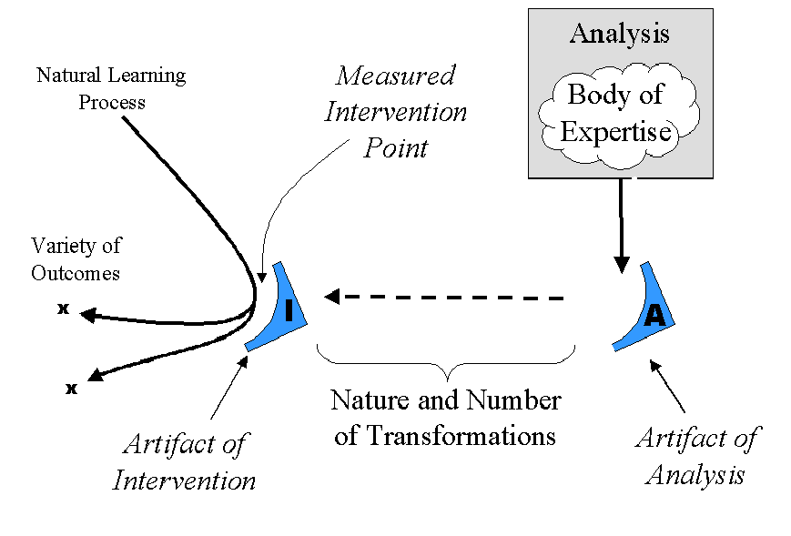
Figure 3. A technological theory of analysis.

At some point in this forward motion of tramsmittal, the structure is impressed on an instructional artifact to create a form that can be “metabolized”. We show this transformation in Figure 3 as design process transformations, and we have labeled the resulting artifact as the artifact of intervention. One assumption of Figure 3 is that intervention can take place at an intervention point that has been measured as an appropriate, perhaps optimal, point for the application of that artifactual intervention.

We describe a methodology that produces artifacts containing problem event structures that can be transformed into a variety of artifacts capable of expression in a variety of forms in a variety of media, through a variety of media constructs. When these media constructs are brought into contact with the learning processes of a student, the course of learning is influenced. The chain of deriving these structures is short, and contrary to past formal views of analysis and design, the order of creation of linked artifacts is reversible and 2-way.

The Resonant Structure

Figure 4 shows that the output of the MCAP methodology is a design element—the problem structure—and that this element is related to three classes of analytic element: environment elements, cause-effect system elements, and elements of expert performance. The arrows in Figure 4 show relationships that create a property we call resonance. The principle of resonance is that any type element of the analysis may be used as an entry point for the systematic derivation of the remaining elements of the other types. For instance, the identification of an environment element leads directly to the identification of system process elements, related expert performance elements, and eventually to problems that involve all of these. Likewise, the identification of a problem allows the designer to work backward to define the environment, system, and expert performance requirements necessary to stage that problem for students. The basic unit of MCAP analysis is this resonant structure.

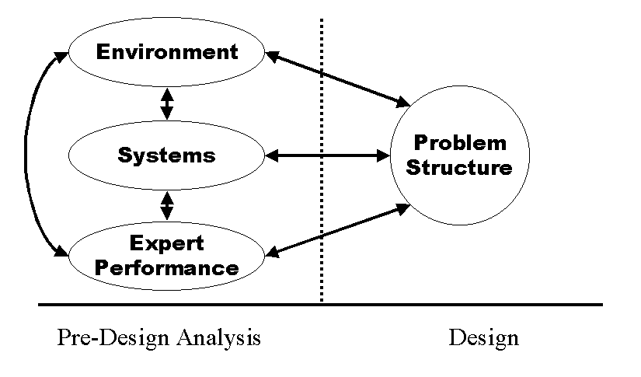
Figure 4. The resonant structure of model-centered analysis.

This resonant relationship exists for all four of the Figure 4 elements in all of the directions indicated by arrows. The implication is that analysis does not necessarily proceed in a top-down manner as is true in most analysis methodologies but that the analyst may move laterally among design elements in a pattern more compatible with a subject-matter expert’s stream of thought. We believe that even traditional forms of analysis proceed more or less in this fashion, even during analyses that are putatively “top-down”. The analysis begins at some initial anchor point and works outward in all directions, sometimes working upward to a new anchor.

Figure 5 shows that each of the element types from Figure 4 participates in a hierarchy of elements of its own kind. These hierarchies can be projected, as it were, on the views of a modeling language. This modeling language, which we have termed an Analysis Modeling Language (AML), is patterned after the Unified Modeling Language (UML) used by programmers to design complex object systems (Booch, Rumbaugh, & Jacobsen, 1999).
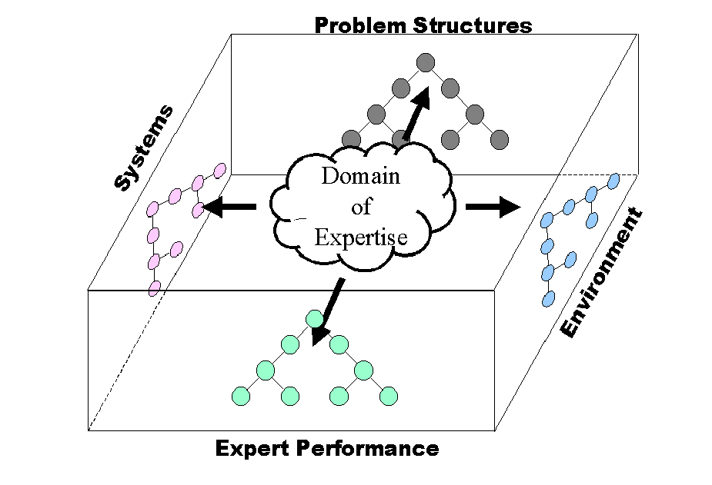
Figure 5. An Analysis Modeling Language providing multiple views into a body of expertise.

This modeling language offers four projected views of a body of expertise: a view of performance environments, a view of cause-effect systems hosted within the environments, and expert performances performed on the cause-effect systems within the environments. The fourth view into the body of expertise consists of situated problem structures from everyday settings that can be used for instructional design purposes. Problems in the problem view are linked with the elements from the other views in resonant relationships.

The benefit of representing the analysis as a set of views linked internally is that the relationships between elements within a view are preserved and can be used to further the analysis. The principle of resonance allows the analyst to move between views, filling in the hierarchy on each of the views. The analyst is also enabled to work within a single view, generating upward and downward from individual elements according to the logic of that individual hierarchy.

For instance, an analyst, having defined a system process, may break the process into its sub-processes showing them hierarchically on the same view and then move to a different view, say the expert performance view, to identify tasks related to the control or use of the sub-processes that were identified in the first view. This may in turn suggest appropriate training problems to the analyst, so the analyst may move to the problem view and record these problems.

The Organization of the Views
The hierarchies of each view differ according to a logic unique to that view:

- The environment view hierarchy breaks the environment into locations that can be navigated by paths. Environment locations are normally nested within each other, and diagrams are often the best representation of their interrelation. However, a simple outline form can capture this relationship also. Paths between locations must be captured in a supplemental form when an outline is used.

- The system view contains three hierarchies under a single head: (1) a raw component hierarchy, (2) a functional subsystems hierarchy, and (3) a system process hierarchy. Examples of these relationships include: (1) the division of an automobile engine into physical components determined by proximity or juxtaposition, (2) the division of an automobile engine into sometimes physically isolated parts that form functional subsystems, such as fuel system, and cooling system, and (3) a separate hierarchy describing processes carried out as forces and information operate and are transformed within the system defined by (1) and (2). The system view in most cases will also include a view of the product produced by expert performance and/or the tools used to produce the product.

- The expert performance view decomposes complex, multi-step performances into progressively simpler performance units according to a parts-of or varieties-of principle. Several systems for cognitive task analysis have been developed that perform this kind of breakdown. Moreover, traditional task analysis accomplishes this type of a breakdown but to a lesser degree of detail and without including key decision-making steps. The expert performance view also decomposes goals that represent states of the systems being acted upon.

- The problem structure view contains a hierarchy of problem structures systematically derivable from the contents of the other views using the parameterized semantic string as a generating device (see description below). This view arranges problems in a multi-dimensional space according to field values in the string structure. As strings take on more specific modifiers they move downward in the hierarchy.

The environment, system, and expert performance views are composed of analytic elements. The problem structure view is composed of design (synthesized) elements that have an analytic function, hence the connection of the problem view to the other three. This makes the set of views, taken together, a bridge between analysis and design.

Entering Analysis from Multiple Points
The principle of resonance allows for multiple entry points into the analysis. The analyst can begin by collecting environment elements, system elements, elements of expert performance, or problem structure elements and organizing them into views, and once information is gathered for one analysis view, resonance automatically leads the designer to questions that populate each of the other views.

Problem Structures: Analysis can begin with a set of constructs normally considered to be on the design side of the analysis-design watershed. This view of analysis means that as analysts we can begin by asking the SME what they think are appropriate performance problems (job situations, common crises, use cases, etc.) for instruction as a means of moving analysis ahead, using constructs from the subject-matter expert (SME)’s world that are already familiar.As a SME begins to generate examples of performance problems, the instructional designer must translate the statements into a semantic string form, either at the time of analysis or in a follow-up documentation period. The instructional designer must also use the resonant relationships principle to identify elements of performance, systems, and environment implicit within problem statements and record them in their respective views. Additional problems can be generated from initial problems by formalizing problem statements into semantic string form and systematically varying string slot contents to create new problem forms.

Expert Performance Structures: Currently there exist a number of tools for both elicitation and recording of expert performance. This area has been the special focus of analysis in the past for both traditional task analysis (TTA) and cognitive task analysis (CTA). TTA has tended to proceed by fragmenting a higher-level task into lower-level components. CTA has tended to look for sequences of tasks, including reasoning and decision-making steps—especially those related to specific characteristics of the operated system. Performance analysis in MCAP incorporates both of these principles, with emphasis on the hierarchical arrangement of tasks because of the generative principle it establishes for continuing analysis using existing tasks to generate new ones.

To expedite analysis with the SME, a use case approach is appropriate for identifying both task fragments and the decisions that join them into longer sequences of performance. A sufficient number of use cases gathered quickly can provide the analyst with a great deal of analysis detail, and in cases of restricted development time can provide a rapid analysis alternative because use cases constitute a basis for problem sets.

Environment Structures: An environment is a system that is not within the immediate scope of instruction. In instruction that uses progressions of models as a method (White & Frederiksen, 1990), what is initially environment eventually emerges into the details of the systems being instructed. Therefore, environment is a relative and dynamic construct. If a particular system is not at the forefront of instruction, in the context of a specific problem, it can be considered the environment or the background for the problem. Environment provides both setting elements and pathing elements for the processes described in the system view of MCAP. An environment description can be quite detailed, and most SMEs tend to accept this as a standard. However, Lesgold ( 1999) and Kieras ( 1988) have recommended that both environment and system definitions need to be limited to useful definitions from the student’s point of view to avoid including irrelevant, unusable information in instruction.

A good starting point for eliciting elements of the environment is to ask the SME for all of the settings where systems exist or performances are required. One way of capturing the environment is as a diagram using AML. Representing an environment graphically helps both SME and instructional designer ensure completeness in the environment view and to use the environment view to extend other views by path tracing.

System structures: Understanding the processes within a system is a prerequisite to explaining behavior and outcomes with respect to that system. A significant source of operator error is the lack of a complete and accurate system model in the learner. It is clear that good system models are the basis for effective expert performance and that as expertise grows the nature of the expert’s system models changes correspondingly (Chi, Glaser, & Farr, 1988; Psotka, Massey, & Mutter, 1988). From our review of the literature we found a number of instructional products that did not succeed as well as they could have because they lacked system process that could be separately articulated. MYCIN (Clancey, 1984), for instance, could not give explanations of expert systems decisions without system models. Instruction that can convey to the learner a complete model the processes that occur within the scope of instruction can provide the learner with a complete explanation of why certain phenomena were observed.

In system process analysis three things must be identified: initiating events, internal processes, and terminating indications. Events that initiate a system process consist of a user action or another process acting from without. Internal processes are represented in a number of ways: as sequential steps, as flow diagrams, or as principles (rules) that control the flow of events.

System structures are captured in the form of: (1) a hierarchy of system components, (2) a hierarchy of functional units made up of individual components, and (3) a tracing of the processes on the face of (1) and (2) on top of the environment description. Process tracings form a multi-dimensional hierarchical form but are best captured as individual tracings, normally related to expert performance elements.

The Semantic String as a Construct for Problem Structure Expression
We feel the model-centered architecture and the model-centered analysis process to be highly relevant to a discussion of instructional objects and their nature and origin because any element of the architecture and any element identified during the analysis may be treated as a type of instructional object. This is consonant with the wide range of objects of different kinds (i.e., instructional, knowledge, learning, etc.) mentioned early in this chapter. Moreover, we feel the problem to be a key structuring object type that allows the designer to connect analysis directly with design and designs directly with tool constructs.

The output of MCAP is a set of problem structures (with their resonant environment, system, and expert performance primitives) that can be used to build an instructional curriculum sequence. A problem structure is a complete and detailed task description expressing a performance to be used during instruction, either as an occasion for modeling expert behavior or as a performance challenge to the learner.

The MCAP problem structure is a data structure. A repeating data structure of some kind is common to all analysis methodologies. This is most evident in traditional task analysis in the repeating nature of tasks at different levels of the hierarchy and in cognitive task analysis in the PARI unit (Hall, Gott, & Pokorny, 1995), the regularity of Anderson's rule forms (Anderson, 1993), and the regular analysis structures by the DNA and SMART (Shute, in press) systems. It is likely that the regularity of these analysis units is closely related to a conceptual unit defined by Miller, Galanter, and Pribram (Miller, Galanter, & Pribram, 1960) called the TOTE (Test-Operate-Test-Evaluate) unit.

The MCAP problem structure is expressed as a semantic string—created by merging data fields from the other three analysis views: (1) environment, (2) cause-effect systems, and (3) expert performance. The semantic string expresses a generic problem structure. During instruction a problem structure is given specific instantiating values. The semantic string does not have an absolute structure and can therefore be adapted to the characteristics of tasks related to individual projects and to trajectories of student progress. However, we believe the string to be conditioned by a general pattern of relationships found in everyday event-script or schematic situations (Schank et al., 1994) in which actors act upon patient systems and materials using tools to create artifacts. We believe this dramatic structure to be related to Schank’s (Schank & Fano, 1992) list of indices.

A general expression of the semantic string consists of the following:

In <environment> one or more <actor> executes <performance> using <tool> affecting <system process> to produce <artifact> having <qualities>.

This general expression of the semantic string can, in turn, be broken down into more detailed parts corresponding to the detailed definition of the environment, of the cause-effect systems, and of the performance.

The general environment portion of the string can be expressed as follows:

In <location> of <environment> in the presence of <external conditions> in the presence of <tool> in the presence of <information resources> in the presence of <material resources>.

The general system portion of the string can be expressed as follows:

Affecting <system> that exists in <state> manifest through <indicator> and operated using <control>.

The general performance portion of the string can be expressed as follows:

One or more <actor(s)> execute <performance> using <method> with <technique>.

Benefits of the Semantic String
One of the functions of analysis is accountability. Analysis becomes a part of the process of requirements tracing (Jarke, 1998) for instructional purposes. Designers must be able to demonstrate that they have achieved some degree of coverage of some body of subject-matter with their instruction.

Accountability requirements have traditionally led to forms of instruction that fill administrative requirements but have little impact on performance. This is especially true when training is regulated and mandated (aviation, nuclear, power distribution, hazardous waste). Accountability in these cases has been equated with verbal coverage, and a formulaic variety of verbal training has become standard in these situations (Guidelines for Evaluation of Nuclear Facility Training Programs, 1994).

Instructional objectives are normally used as the accountability tool in forming this type of instruction, and in some cases traditional task analysis methods are used as a means of grounding the objectives in a systematic process to certify soundness and completeness. Accountability in this atmosphere is difficult, and sometimes task analysis principles have to be stretched in order to make the accountability connection.

Acceptance of problem solving as appropriate form of instruction and assessment makes the accountability problem harder. It creates new problems for accountability, because the basic construct of accountability changes from the verbal check-off to the real and dynamic competency. Instructional designers lack the ability to express dynamic competency and also lack a theory of performance measurement that would generate appropriate performance assessments.

The semantic string mechanism supplies a method for the description of dynamic competency. When the string is instantiated with specific values or with a range of values, it expresses a specific problem or range of problems. Variations of string values make this an expression of a range of performance capability.

Generating Problems and Using Weighting To Focus Problem Sets
Instructional problems are generated computationally using the semantic string by defining a range of values for each field in the string and then systematically substituting values in specific string positions. Generation of problems using the semantic string takes place in two steps: (1) insertion of values from the hierarchically-organized views into the string to create a problem, and (2) selection of specific initial values that instantiate the problem. This results in a geometric proliferation of possible problems, so mechanisms capable of narrowing and focusing problem sets into sequences are important.

This is accomplished by selecting string values depending on the principle the designer is trying to maximize within a problem sequence. A few possible sequence principles are given here as examples:

- Maximum coverage in limited time—String values will be selected with the minimum of redundancy. Each problem will contain as many new elements in string positions as possible.

- Cognitive load management—String values will be selected in terms of their addition to the current cognitive load. Increases may be due to increased memory requirement, coordination of conflicting sensory demands, integration of parallel decision processes, or a large number of other possibilities. Each string element is judged according to its contribution to load.

- Integration of complexes of prior learning—String values are selected as combinations of elements from each of the view hierarchies that practice already mastered areas of the hierarchies in new combinations.

- Decontextualization of skills—String values are selected so that they vary systematically, preserving expert performance elements but varying environment and system elements as widely as possible. Core performances are retained in the string but to them are added as wide a variety as possible of non-related performances.

- Practice to automaticity—String values are kept as unchanged as possible with the exception of the conditions in the environment, which change in terms of timing factors where possible.

- Transfer—String values for expert performance change along a dimension in which performances in the sequence contain similar elements. Environment and system string elements are made to vary widely.

- Risk awareness—String values are selected on the basis of weightings attached to performances, system processes, and environmental configurations that have historically posed or have the potential for posing risks.

When string values have been selected, individual problems are instantiated by the designer by specifying data that situates the problem. This data includes:

- Environment configuration data—Data that describes the specific environment in which the problem will be presented to the learner.

- Environment initialization data—Data that describes variable values of the environment at problem initiation.

- System configuration data—Data that describes the configuration of systems that the student will interact with or observe.

- System initialization data—Data that describes variable values of the systems at the beginning of the problem.

- Problem history—Data that describes the history of events that has brought the problem to its present state.

- Problem end state data—Data that describes the states of system and environment at the end of the successfully concluded problem.

Relation to Instructional Objects

Instructional objects, under their several names, are often referred to in the literature as if they were a well-defined, unitary element. However, they must be seen in terms of their place in an architectural hierarchy capable of finding, comparing, and selecting them and then joining them together to perform an orchestrated instructional function that requires more than a single object can accomplish unless it is a self-contained instructional product. An architectural superstructure capable of employing objects in this way is described in the Learning Technology Systems Architecture (LTSA) (Farance & Tonkel, 1999).

This architecture will require a variety of object types, some of them merely content-bearing, but some of them consisting of functional instructional sub-units of many kinds, including in many cases interactive models and related sets of problems defined with respect to the models.

Peters, for instance, describes how “…‘knowledge objects’ enabled by [an] emergent class of digital libraries will be much more like ‘experiences’ than they will be like ‘things’, much more like ‘programs’ than ‘documents’, and readers will have unique experiences with these objects in an even more profound way than is already the case with books, periodicals, etc.” (Peters, 1995). This in turn suggests the need for model components that can be brought together in various combinations to create the environments and systems for progressions of problems.

For example, a telephone switch manufacturer, in order to align training objects with training content and to reuse the same objects in multiple training contexts, might create models of three different PBXs (switches) and two different telephone sets, a desk set and a handset, that can be connected in different configurations. The same models could be used for numerous training problems for the installer, the maintainer, and the operator. The independent problem sets (themselves a type of instructional object) would consist of the list of models to be connected together for a particular problem: initial values, terminal (solution) values, and instructional data to be used by independent instructional functionalities (coaches, feedback givers, didactic givers) in conjunction with the problems. The instructional agents, of course, would be a variety of instructional object as well.

MCAP provides a shared methodology basis for deriving suites of model objects interoperable not only with themselves but with instructional agents that share the model-centered instructional viewpoint. The important idea here is not that model-centered principles are right for all occasions but that the creation and use of instructional objects benefits from a process capable of coordinating instructional assumptions with object outlines and connections.

This is the principle we have been exploring with MCAP. We have found it useful to describe a model-centered instructional product architecture that aligns with several layers of design (see Figure 1): instructional models, instructional strategies, instructional problems, instructional message elements, representation, and media-logic. At the same time it allows these levels of design to be integrated into running products, it allows them maximum portability and reusability in a number of modes. Instructional functions can be added independently of model function. The model-centered architecture is illustrated in Figure 6 below and includes:

- A problem solving environment that contains everything
- A problem environment that contains information-bearing locations
- The paths for navigating between locations
- Cause-effect or event models invisible to the viewer
- Controls and indicators within locations, connected to the models
- One or more problems to be solved within the problem environment
- Models of expert performance that can be observed
- Resources that supply information for use in problem solution
- Tools that can be used to generate information or to record information
- Instructional augmentations that offer coaching, feedback, interpretations,
explanations, or other helps to problem solving

Relation to the Goals of CBI: Adaptivity, Generativity, and Scalability

Most importantly, linking the origin of instructional objects to the design process—through analysis and design constructs—appears to change the analysis and design process itself in a way that produces primitives that can be used to meet the CBI goals of adaptivity, generativity, and scalability.

Adaptivity is obtained as independent instructional objects are assembled and implemented in response to current learner states. The granularity of adaptivity in object architectures will correspond to the granularity of the objects themselves and the instructional rules that can be generated to control the operations of objects. MCAP is flexible with respect to granularity because it represents elements of environments, systems, and expert performance at high levels of consolidation or at very detailed and fragmented levels. The granularity of object identification can be adjusted to any level between these extremes. This is one of the characteristics that allows MCAP to provide useful analysis and design functionality to both small-scale and low-budget development projects (that will use instructors and overhead projectors) as well as the large-scale, well-financed ones (that may at the high end venture into intelligent tutoring methods).

Generativity is also favored by an analysis that identifies at a high level of granularity the terms that might enter into the instructional dialogue at any level. Generativity is not a single property of computer-based instructional systems but rather refers to the ability of the system to combine any of several instructional constructs with tool and material constructs on the fly: instructional model suites, instructional problems and problem sequences, instructional strategies, instructional messages, instructional representations, and even instructional media-logic. The semantic string method of problem expression—though computationally impractical without adequate data to guide the generation of problems—can, if provided with that data, lead designers to the generation of progressive problem sets and can make possible for computer-based systems the generation of problem sequences.

Figure 6. Model-centered instructional architecture.

Scalability involves production of quantity at specified levels of quality within specified time and resource constraints. It also requires an increase in productivity without a proportional increase in production cost. Instructional object technology cannot now provide scalability because the infrastructure of skills, tools, and processes is not available that would support this. Scalability, however, is one of the main arguments provided in promoting instructional object economies (Spohrer, Sumner & Shum 1998), and adequate technologies for designing and using objects will modify instructional development costs in the same way that roads, gas stations, and mechanic shops modified automobile costs.

Conclusion

Our purpose has been to set instructional objects within a design process context. Standardization efforts related to object properties and indexing will open the floodgates for object manufacture and sharing, but without attention to design process, interoperability among all the necessary varieties of instructional objects and the favorable economics needed to sustain their use will not materialize.

References

Advanced Distance Learning Initiative. (http://www.adlnet.org).

Anderson, J. R. (1993). Rules of the Mind. Hillsdale, NJ: Lawrence Erlbaum Associates.

Atkinson, R. C. & Wilson, H. A. (1969a). Computer-Assisted Instruction: A Book of Readings. New York: Academic Press.

Atkinson, R. C. & Wilson, H. A. (1969b). Computer-Assisted Instruction. In R. C. Atkinson & H. A. Wilson, Computer-Assisted Instruction: A Book of Readings. New York: Academic Press.

Booch, G., Rumbaugh, J., & Jacobsen, I. (1999). The Unified Modeling Language User Guide. Reading, MA: Addison-Wesley.

Brand, S. (1994). How Buildings Learn: What Happens After They’re Built. New York: Penguin Books.

Burns, H. & Parlett, J. W. (1991). The Evolution of Intelligent Tutoring Systems: Dimensions of Design. In H. Burns, J. W. Parlett, & C. L. Redfield (Eds.), Intelligent Tutoring Systems: Evolutions in Design. Hillsdale, NJ: Lawrence Erlbaum Associates

Burns, H., Parlett, J. W., & Redfield, C. L. (1991). Intelligent Tutoring Systems: Evolutions in Design. Hillsdale, NJ: Lawrence Erlbaum Associates

Chi, M., Glaser, R., & Farr, M. (1988). The Nature of Expertise. Hillsdale, NJ: Lawrence Erlbaum Associates.

Clancey, W. J. (1984). Extensions to Rules for Explanation and Tutoring. In B. G. Buchanan & E. H. Shortliffe (Eds.), Rule-Based Expert Systems: The Mycin Experiments of the Stanford Heuristic Programming Project. Reading, MA: Addison-Wesley.

Duffin, J. R. & Gibbons, A. S. (in preparation). Alignment and Decomposition in the Design of CBI Architectures.

Edmonds, G. S., Branch, R. C. & Mukherjee, P. (1994). A Conceptual Framework for Comparing Instructional Design Models. Educational Technology Research and Development, 42(4), 55-72.

Fairweather, P. G. & Gibbons, A. S. (2000). Distributed Learning: Two Steps Forward, One Back? Or One Forward, Two Back? IEEE Concurrency, 8(2), 8-9, 79.

Farance, F. & Tonkel, J. (1999). Learning Technology Systems Architecture (LTSA). (http://edutool.com/ltsa/)

Gerard, R. W. (1969). Shaping the Mind: Computers In Education. In R. C. Atkinson & H. A. Wilson, Computer-Assisted Instruction: A Book of Readings. New York: Academic Press.

Gibbons, A. S. (1998). Model-Centered Instruction. Paper presented at the Annual Meeting of the American Education Research Association, San Diego, CA.

Gibbons, A. S. (in press). Model-Centered Instruction. Journal of Structural Learning and Intelligent Systems.

Gibbons, A. S., Bunderson, C. V., Olsen, J. B. & Robertson, J. (1995). Work Models: Still Beyond Instructional Objectives. Machine-Mediated Learning, 5(3&4), 221-236.

Gibbons, A. S. & Fairweather, P. G. (1998). Computer-Based Instruction: Design and Development. Englewood Cliffs, NJ: Educational Technology Publications.

Gibbons, A. S. & Fairweather, P. G. (in press). Computer-Based Instruction. In S. Tobias & J. D. Fletcher (Eds.), Training and Retraining: A Handbook for Business, Industry, Government, and Military. New York: Macmillan Reference.

Gibbons, A. S., Fairweather, P. G., Anderson, T. A. & Merrill, M. D. (1997). Simulation and Computer-Based Instruction: A Future View. In C. R. Dills & A. J. Romiszowski (Eds.), Instructional Development Paradigms. Englewood Cliffs, NJ: Educational Technology Publications.

Gibbons, A. S., Lawless, K., Anderson, T. A. & Duffin, J. R. (in press). The Web and Model-Centered Instruction. In B. Khan (Ed.), Web-Based Training. Englewood Cliffs, NJ: Educational Technology Publications.

Gibbons, A.S., Nelson, J. & Richards, R. (2000a). Theoretical and Practical Requirements for a System of Pre-Design Analysis: State of the Art of Pre-Design Analysis. Center for Human-Systems Simulation, Idaho National Engineering and Environmental Laboratory, Idaho Falls, ID.

Gibbons, A.S., Nelson, J. & Richards, R. (2000b). Model-Centered Analysis Process (MCAP): A Pre-Design Analysis Methodology. Center for Human-Systems Simulation, Idaho National Engineering and Environmental Laboratory, Idaho Falls, ID.

Gordon, J. & Zemke, R. (2000). The Attack on ISD. Training, April, 43-53.

Graves, W. H. (1994). Toward A National Learning Infrastructure. Educom Review, 29(2). (http://www.educause.edu/pub/er/review/reviewArticles/29232.html)

Guidelines for Evaluation of Nuclear Facility Training Programs ( DOE-STD-1070-94)(1994). Washington, D.C.: U.S. Department of Energy.

Hall, E. P., Gott, S. P., & Pokorny, R. A. (1995). Procedural Guide to Cognitive Task Analysis: The PARI Methodology ( AL/HR-TR-1995-0108). Brooks, AFB, TX: Armstrong Laboratory, Human Resource Directorate.

Hannafin, M. J., Hannafin, K. M., Land, S. M. & Oliver, K. (1997). Grounded Practice and the Design of Constructivist Learning Environments. Educational Technology Research and Development, 45(3), 101-117.

Hill, T. (1998). Dimensions of the Workforce 2008: Beyond Training and Education, Toward Continuous Personal Development. Paper presented at Technology Applications in Education Conference, Institute for Defense Analyses, Alexandria, VA, December 9-10.

Jarke, M. (1998). Requirements Tracing. Communications of the ACM, 41(2).
Kieras, D. E. (1988). What Mental Models Should Be Taught: Choosing Instructional Content for Complex Engineered Systems. In J. Psotka & D. L. Massey & S. A. Mutter (Eds.), Intelligent Tutoring Systems: Lessons Learned (pp. 85-111).

Lesgold, A. M. (1999). Intelligent Learning Environments for Technical Training: Lessons learned. In A. K. Noor (Ed.), Workshop on Advanced Training Technologies and Learning Environments. Hampton, VA: NASA Langley

Merrill, M. D. (1994). Instructional Design Theory. Englewood Cliffs, NJ: Educational Technology Publications.

Merrill, M. D. and the ID2 Research Group (1996). Instructional Transaction Theory: Instructional Design Based On Knowledge Objects. Educational Technology, 36(3), 30-37.

Miller, G. A., Galanter, E., & Pribram, K. H. (1960). Plans and the Structure of Behvior. New York: Henry Holt and Company, Inc.

Misa, T. J. (1995). A Nation of Steel. Baltimore, MD: Johns Hopkins University Press.

Montague, W. E. (1988). Promoting Cognitive Processing and Learning by Designing the Learning Environment. In D. Jonassen (Ed.), Instructional Designs for Microcomputer Courseware. Hillsdale, NJ: Lawrence Erlbaum Associates.

Noor, A. K. (1999). Advanced Training Technologies and Learning Environments: Proceedings of a workshop sponsored by NASA and the Center for Computational Technology (University of Virginia). March, NASA/CP-1999-209339.

Peters, P. E. (1995). Digital Libraries Are Much More Than Digitized Collections. Educom Review, 30(4), July/August. (http://www.educause.edu/pub/er/review/reviewArticles/30411.html)

Poulson, M. C. & Richardson, J. J. (1988). Foundations of Intelligent Tutoring Systems. Hillsdale, NJ: Lawrence Erlbaum Associates.

Psotka, J., Massey, D. L., & Mutter, S. A. (1988). Intelligent Tutoring Systems: Lessons Learned. Hillsdale, NJ: Lawrence Erlbaum Associates.

Reigeluth, C. M. (1999). Instructional-Design Theories and Models: A New Paradigm of Instructional Theory, Volume II. Mahwah, NJ: Lawrence Erlbaum Associates.

Rowland, G. (1993). Designing Instructional Design. Educational Technology Research and Development, 41(1), 79-91.

Schank, R. C., & Fano, A. (1992). A Thematic Hierarchy for Indexing Stories. Evanston, IL: The Institute for the Learning Sciences, Northwestern University.

Schank, R. C., Kass, A., & Riesbeck, C. K. (Eds.). (1994). Inside Case-Based Explanation ( Vol. 3). Hillsdale, NJ: Lawrence Erlbaum Associates.

Shute, V. J. (in press). DNA: Towards an Automated Knowledge Elicitation and Organization Tool. In S. P. Lajoie (Ed.), Computers as Cognitive Tools: No More Walls (2nd ed.). Mahwah, NJ: Lawrence Erlbaum Associates.

Silberman, H. F. (1969). Applications of Computers in Education. In R. C. Atkinson & H. A. Wilson, Computer-Assisted Instruction: A Book of Readings. New York: Academic Press.

Spohrer, J. Sumner, T. & Shum, S. B. (1998). Educational Authoring Tools and the Educational Object Economy: Introduction to the Special Issue From the East/West Group. Journal of Interactive Media In Education. (http://www-jime.open.ac.uk/98/10/spohrer-98-10-paper.html)

Stolurow, L. M. (1969). Some Factors in the Design of Systems for Computer-Assisted Instruction. In R. C. Atkinson & H. A. Wilson, Computer-Assisted Instruction: A Book of Readings. New York: Academic Press.

Suppes, P. (1969). Computer Technology and the Future of Education. In R. C. Atkinson & H. A. Wilson, Computer-Assisted Instruction: A Book of Readings. New York: Academic Press.

Wenger, E. (1987). Artificial Intelligence and Tutoring Systems: Computational and Cognitive Approaches to the Communication of Knowledge. Los Altos, CA: Morgan Kaufmann.

White, B. Y. & Fredricksen, J. (1990). Causal Model Progressions As A Foundation for Intelligent Learning Environments. Artificial Intelligence, 24, 99-157.

This chapter describes research on the instructional design process carried out under the auspices of the Human-System Simulations Center at the Idaho National Environmental and Engineering Laboratory (Department of Energy).

